# CS 255 System Design Document Template

## UML Diagrams

### UML Use Case Diagram

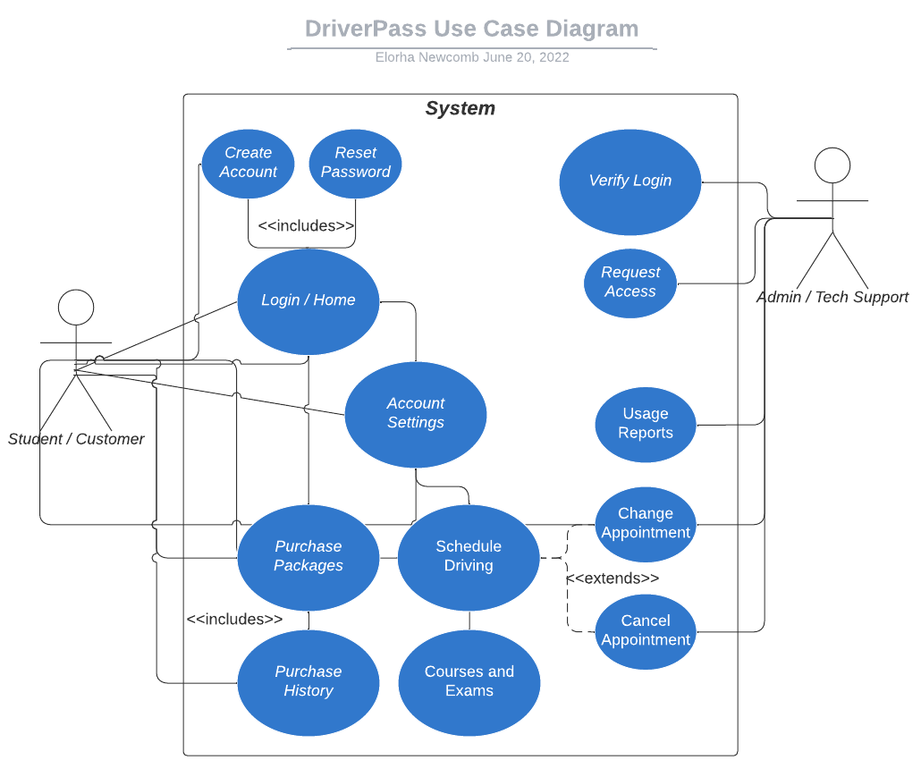

### 

### UML Activity Diagrams

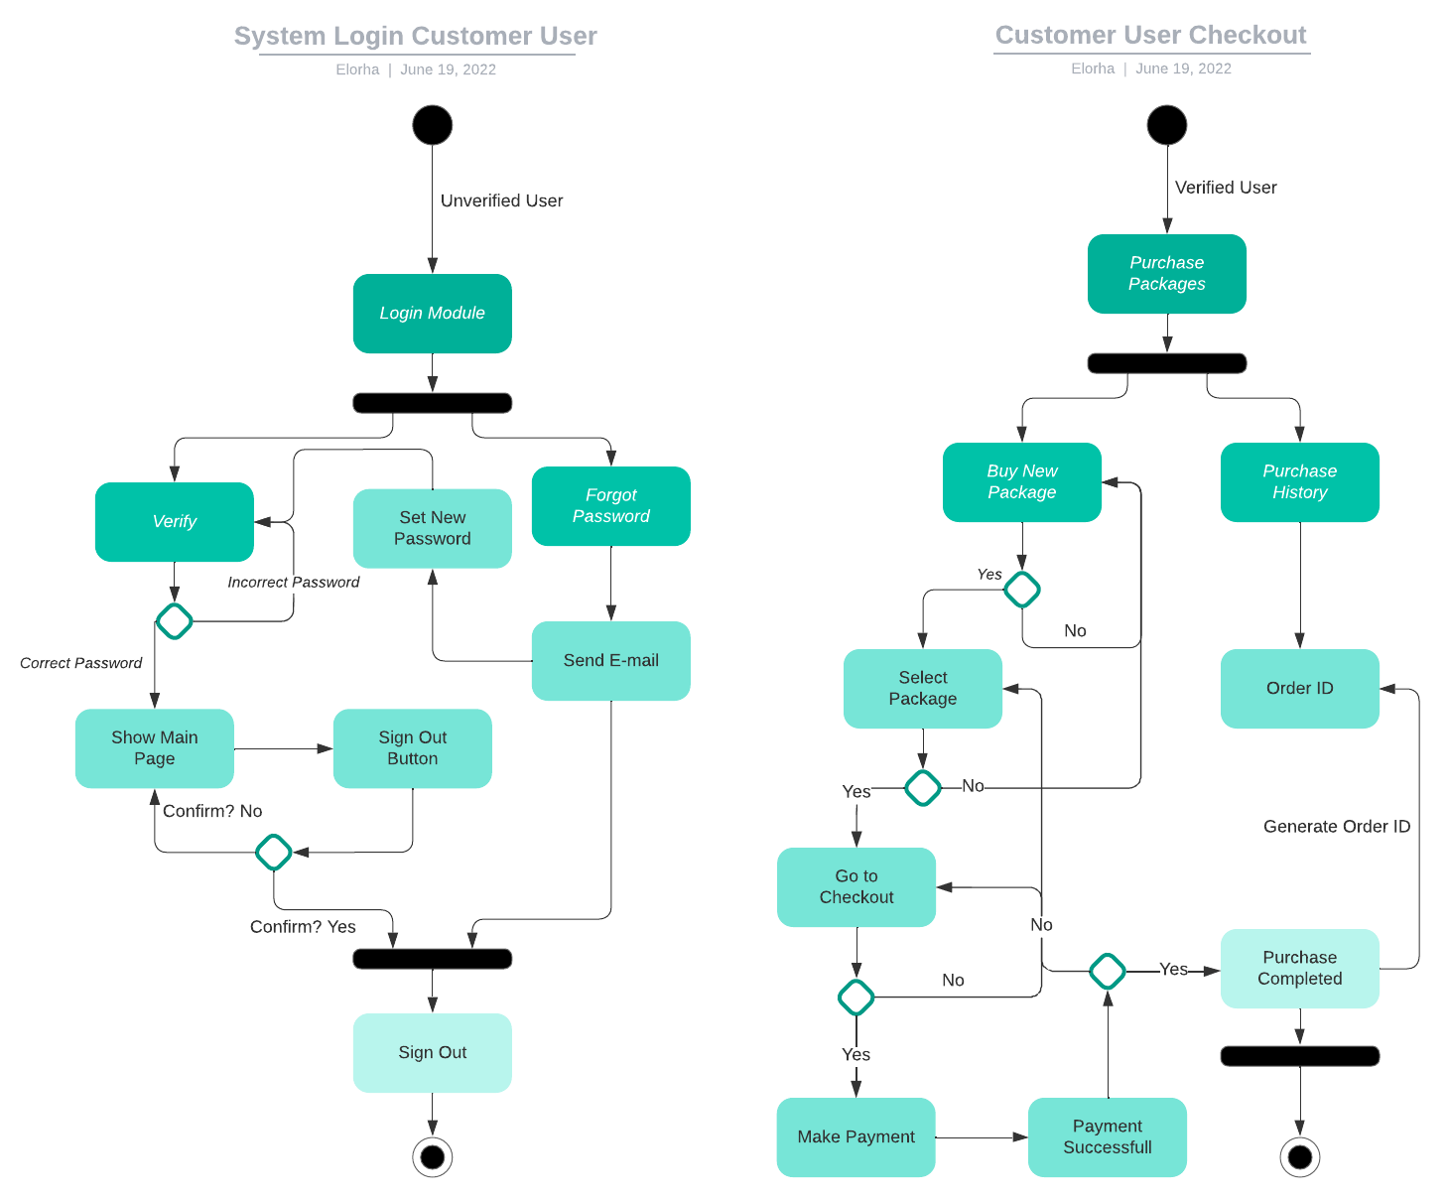

### UML Sequence Diagram

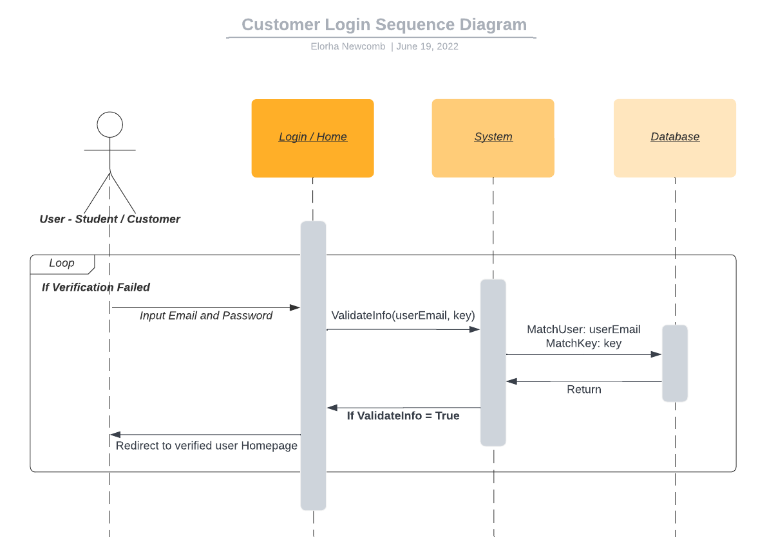

### UML Class Diagram

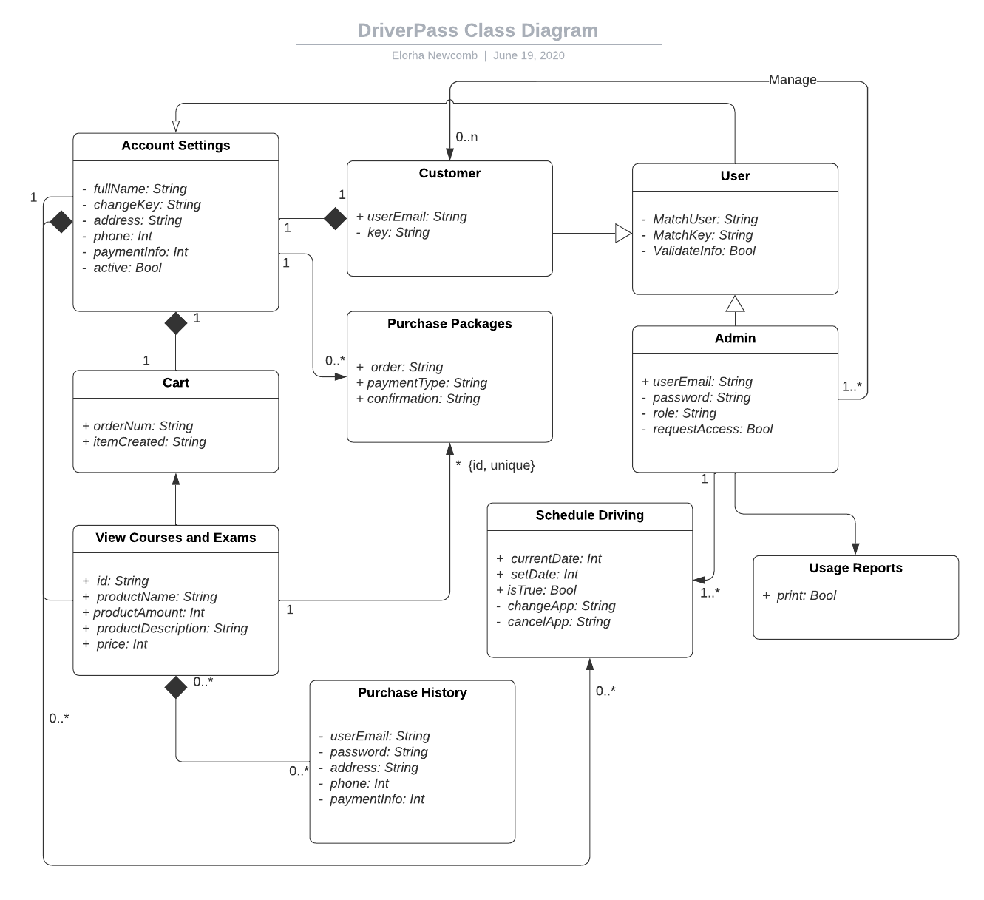

## Technical Requirements

The product currently being developed for the client DriverPass will be a web-based application, domain will be provided by the client and will be hosted in their third-party web-hosting of choice, as long as it conforms to system requirements; regularly updated for security reasons, maintainable and compatible with most desktop and mobile devices. Firebase will be used during development and as a NoSQL database, which will inherit data from the current client’s system during migration. PayPal will be used as the main payment method, followed by Venmo. Access to the DMV will be granted with access key provided to DriverPass by the department.